**The following are our offering so far:**

**Expense management solution**

1. Individual expenses
2. Project expenses and income
3. Organization expenses and income
4. Taxes

**Finance management system**

1. By tracking money flow
2. Quick analysis and reporting
3. Distributing work
4. Tax calculations
5. Reporting

**Xpen, the following features are offered by Xpen with some additional HR administration tools like**:

1. Payroll
2. Employees expenses accounting

Xpen Dashboard

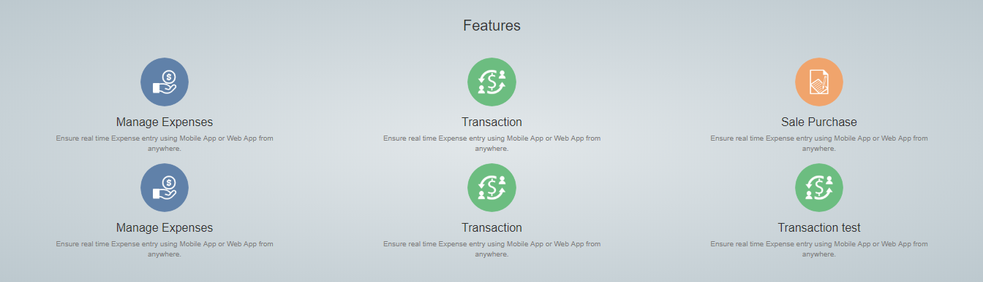

**Recommendations on the features:**

1. **Invoicing & Bills**
2. **Sales order & purchase order**
3. **GST**
4. **Document & Reporting**
5. **Estimate and Expense**
6. **Inventory**
7. **Banking**
8. **Automation**

The following features can be added in our office accounting offering in Xpen as these above features are the most demanded among the corporates.

**Recommendations on the features:**

1. **Real time attendance**
2. **Automated data entry instead of cluster of sheets**
3. **Payroll reports**
4. **Leave reports**
5. **Performance evaluation report**
6. **HR supply & demand analysis**
7. **Case managements & Grievances Tickets**

The following features can be added in our HR administrator offering in Xpen as these above features are the most demanded among the corporates.